## Business Intelligence with SharePoint 2010

**Lab Time**: 45 minutes

**Lab Folder**: C:\Student\Labs\BusinessIntelligence

**Lab Overview:** The purpose of this lab is to demonstrate the Business Intelligence (BI) capabilities of SharePoint Server 2010. You will begin by using the Chart Web Part to create graphical representations of data within SharePoint lists. Next, you will play the role of an analyst using Microsoft Excel 2010 to examine and data from SQL Server Analysis Services. After creating an Excel workbook that displays BI information, you will then publish the workbook with Excel Services to make it accessible to users using the browser. In the final exercise, you will work with a PerformancePoint Services site and the new Dashboard Designer to create a dashboard for the executive management team at Adventure Works.

In this lab, you will be working with sales data that has been generated from the Adventure Works database. The screenshot below will give you an idea of how the Adventure Works data on sales revenue spans across four years from 2001 to 2004 and is divided up between six different counties.



In exercise 1, you will display this data using the Chart Web Part pulling the data from standard SharePoint lists within a SharePoint site. Note that you can also use the Chart Web Part to pull data from external lists in scenarios where the data lives in backend databases and line of business applications. The main reason that exercise 1 focusing on the Chart Web Part does not use external data is to save time so you can move on the exercises with Excel Services and PerformancePoint as well.

In exercises 2 and 3, you will pull the same data from a cube served up by SQL Server 2008 Analysis Services. This lab assumes that SQL Server 2008 Analysis Services has been properly installed in your environment and that the **AdventureWorks 2008 Analysis Services Project** sample has been properly deployed.

Lab Setup Requirements

* Before you begin this lab, you must run the batch file named **SetupLab.bat**. This batch file creates a new blank site collection at the location **http://intranet.wingtip.com/sites/BusinessIntelligence**. It also runs a utility to create two lists that will be used in exercise 1. This is the site you will use to create chart Web Parts, publish Excel Workbooks and create a Dashboard using Performance Point Services.

### Exercise 1: Using the Charting Web Parts

In this exercise you will use the Chart Web Part to provide a simple way to provide charts on a Web Part page so that users can visualize data in native lists within a SharePoint site as well as external lists created with the BCS. For the sake of time, this exercise will use a SharePoint list but keep in mind that the techniques you learn to display charts using the Chart Web Part can also be based on data from backend systems.



1. Refresh the browser. After doing this, you should be able to verify that the site contains two lists named **Sales by Country** and **Sales by Year**. You should be able to navigate to these lists using links from the Quick Launch Bar.



1. The Chart Web Part is part of the Enterprise Edition of SharePoint Server 2010. Therefore, you must activate a specific feature of the Enterprise Edition before you can use the Chart Web Part.
2. Select the **Site Actions » Site Settings**.
3. Inside the **Site Collection Administration** section of the Site Settings page, select **Site collection features**.
4. **Activate** the feature titled **SharePoint Server Enterprise Site Collection Features**. Activation of the feature is what makes the Chart Web Part available.
5. Navigate to the home page of the site at **/Pages/default.aspx**. Check the page out and place it into **Edit** mode using the ribbon and **Page** tab. To get the ribbon to appear, select **Site Actions » Show Ribbon**.
6. Add an instance of the **Chart Web Part** to **Pages/default.aspx** using the following steps:
7. While in edit mode, click on the **Main** Web Part Zone to ensure it is selected. At this point, the **Page Tools** tab group should appear with the **Insert** tab.
8. Click on the **Insert** tab and then click the **Web Part** button.
9. Select the **Chart Web Part** from the **Business Data** folder and click the **Add** button place it on the page.



1. Once the Chart Web Part has been added to the page, you should see a link with the caption of **Data and Appearance**. Click on this link to launch a wizard that will allow you to select a data source.

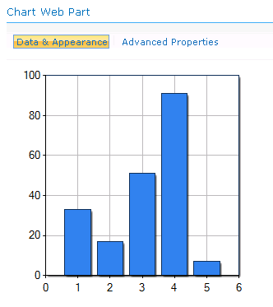

1. Follow these steps to move through the wizard and connect the Chart Web Part to a SharePoint list as its data source.
2. On the first page of the wizard, click the link which reads **Connect Chart To Data**.
3. The next page asks you to select a data source. Choose **Connect to a List**.
4. The next page asks you to pick a site and a list. Leave the current site as the selected site and make sure **Sales by Country** is selected as the target list.
5. The next page shows you the data from the list but requires no action. Click **Next**.
6. The next and final step of the wizard allows you to bind your chart to the data. Fill out this page as the screenshot shown below and click **Finish**.

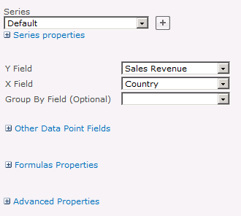

1. At this point you should have a basic bar chart. Now you need to convert it into a pie chart and make it look more polished. Click the **Data and Appearance** link again and do the following:
2. On the first page of the wizard click **Customize Your Chart**.
3. The next page allows you to pick a chart type. Under **Chart Type Categories** select **Pie**. Select the **2D Chart Types** tab and select the first chart type with the caption of **Pie**. Click **Next**.

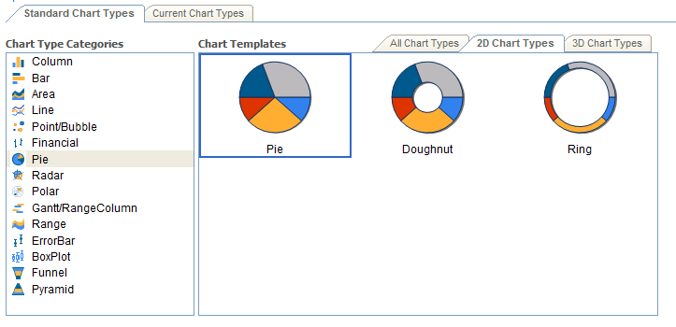

1. The next page allows you to change visual aspects of the chart. Change the Chart **Width** from **300px** to **800px**. Change the Chart **Height** from **300px** to **400px**. Click **Next**.
2. On the next page, click the checkbox which reads **Show Legend**. Add a legend title of **"Sales By Country”.**

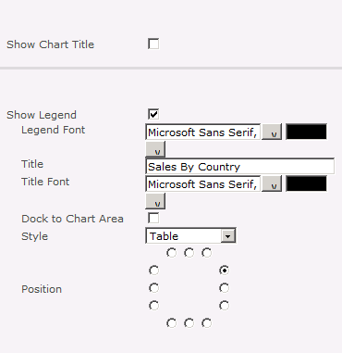

1. Click **Finish** to complete the wizard and to see the chart which should look like the one shown below.

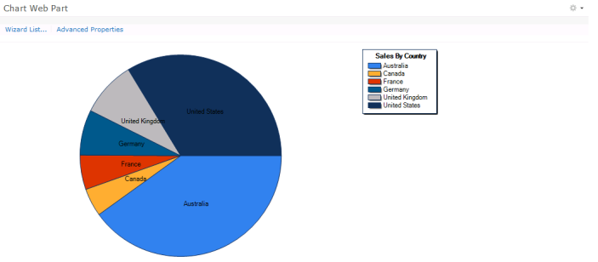

1. Now you will add a second instance of the Chart Web Part to **Pages\default.aspx** so you can also chart the sales data inside the **Sales By Year** list.
2. Select **Site Actions » Edit Page** command to place **Pages\default.aspx** into edit mode.
3. Click on the **Main** Web Part Zone to ensure it is selected. At this point, the **Page Tools** tab group should appear with the **Insert** tab.
4. Click on the **Insert** tab and then click the **Web Part** button.
5. Select the **Chart Web Part** from the **Miscellaneous** folder and click the **Add** button to place it on the page.



1. At this point the new Chart Web Part instance should appear above the Chart Web Part you created with the pie chart.
2. Click on the **Data and Appearance** link on new Chart Web Part instance so you can select a data source.
3. On the first page of the wizard, click the link which reads **Connect Chart To Data**.
4. The next page asks you to select a data source. Choose **Connect to a List**.
5. The next page asks you to pick a site and a list. Leave the current site as the selected site and make sure **Sales By Year** is selected as the target list.
6. The next page shows you the data from the list but requires no action. Click **Next**.
7. The next and final step of the wizard allows you to bind your chart to the data. Fill out this page as the screenshot shown below and click **Finish**.

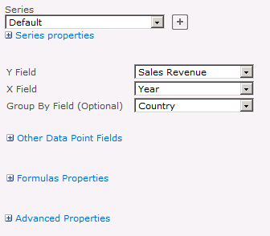

1. At this point you should have a basic bar chart. Now you need to convert it into a line chart and make it look more polished. Click the **Data and Appearance** link again and follow these steps.
2. On the first page of the wizard click **Customize Your Chart**.
3. The next page allows you to pick a chart type. Under **Chart Type Categories** select **Line**. Select the **2D Chart Types** tab and select the chart type with the caption of **Line with no Margin**. Click **Next**.

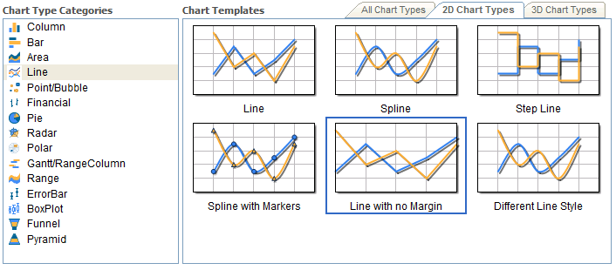

1. The next page allows you to change visual aspects of the chart. Change the Chart **Width** from **300px** to **800px**. Change the Chart **Height** from **300px** to **400px**. Click **Next**.
2. On the next page, click the checkbox which reads **Show Legend**. Add a legend title of **"Sales By Country”**

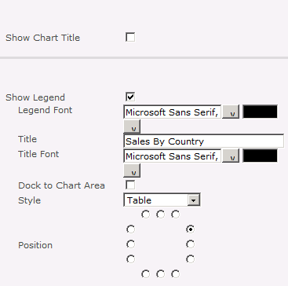

1. Click **Finish** to complete the wizard and to see the chart which should look like the one shown below.

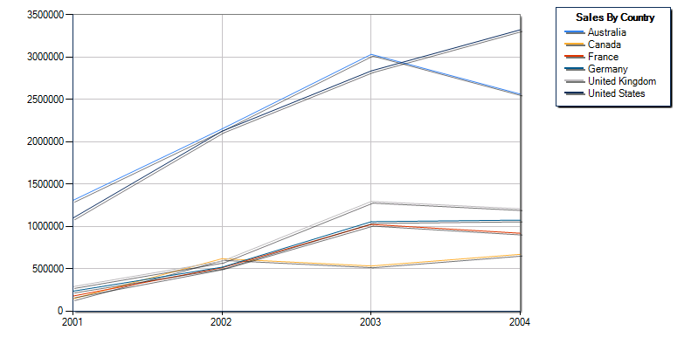

In this exercise you added and customized two Chart Web Parts to the SharePoint site based off data in a SharePoint list.

### Exercise 2: Performing Analysis with Excel and Excel Services

In this exercise you will work with the Microsoft Office Excel 2010 client application. Throughout this exercise you will utilize the Excel client integration points into SPF2010 sites and Excel Services.

1. In the browser, navigate to the site **http://intranet.wingtip.com/sites/BusinessIntelligence**. There should be a document library named **Excel Workbooks.** This is the location to which you will publish Excel workbooks in this lab exercise.
2. At this point, you should be at the page with the default view for the **Excel Workbooks** document library. Create a new Excel workbook: **Start » All Programs » Microsoft Office 2010 » Microsoft Excel 2010**.
3. Starting in cell **B:3,** create a simple set of Adventure Works sales data from which you can create a pie chart. Make one column on the left with country names. Make a second column on the right with sales figures for these countries. Use the following screenshot to fill in the sample data. Also add a title to cell **B:2** and do a little formatting work to make the title stand out.

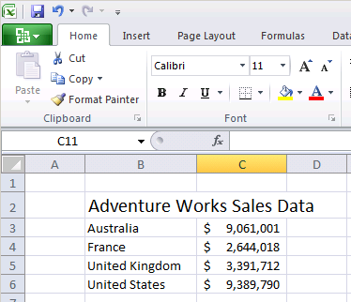

1. Now create a chart from this data.
2. Select a range of cells which includes both columns of data.
3. Up on the ribbon, select the **Insert** tab.
4. Drop down the **Pie** menu and select the first Pie chart.

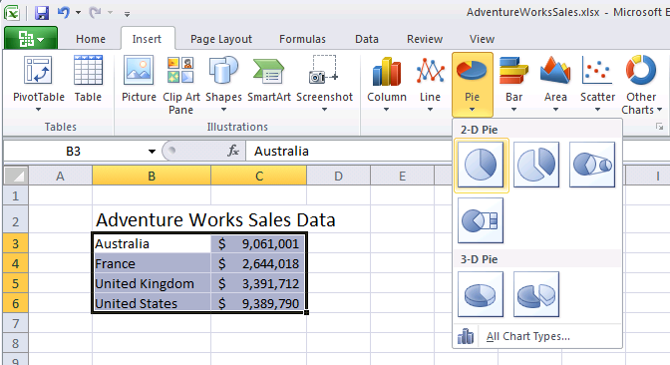

1. Once you have created the chart, you will need to resize and relocate it. Spend about 60 seconds trying to make the workbook as a whole look as pretty as possible.

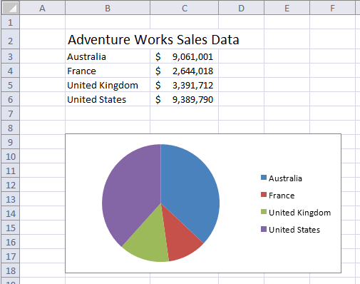

1. Now save your work using the standard Excel **Save** command. Make sure you save the new workbook in the **Excel Workbooks** document library with a name of AdventureWorksSales.xls.
2. Over the next few steps, you will publish the workbook into Excel Services. However, this step has been added to give you an understanding of trusted file locations. While you will not be required to take any actions to configure trusted file locations in this lab exercise, you can follow these steps so you can see where and how trusted file locations are configured.
3. Open **Central Administration**.
4. In the **Application Management** section, click **Manage service applications**.
5. Click on the link titled **Excel Services**. Doing this should highlight the row and enable service buttons in the ribbon.
6. In the ribbon, click the Manage button. This will take you to the main administrative page for Excel Services.
7. Click on the **Trusted File Locations** link.
8. On your VM, you should see that there is already a trusted file location configured with an URL of **http://**. Click on this trusted file location so you can see its configured settings. Note that the checkbox with the caption of **Children Trusted** is checked. If you scroll down to the **External Data** section, you can there is a property named **Allow External Data** with a setting value of **Trusted data connection libraries and embedded**. This allows users to publish workbooks with both kinds of data connections.

**Note:** There has been nothing for you to do in these last few steps other than observe because the VM you are using already has a trusted file location that will allow you to do your work. However, while Excel Services by default allows users to publish Excel workbooks anywhere in the farm using any type of connection, do not assume this will always be the case. In secure environments, the IT staff will remove this default trusted file location and only add trusted file locations at a much narrower scope and not allow for embedded connections.

1. Now you will publish the workbook to Excel Services using the following steps.
2. Select the **File** button (i.e. the green button at the top-left of the screen) from the ribbon.
3. In the left column, click on **Save & Send.**
4. In the middle column click on **Save to SharePoint.**
5. In the right column click the button **Save As.**
6. The **Save As** dialog appears. Note that unlike the usual Save As dialog. That this dialog has a button in the bottom section with the caption **Publish Options…**. Click this button to display the **Publish Options** dialog.

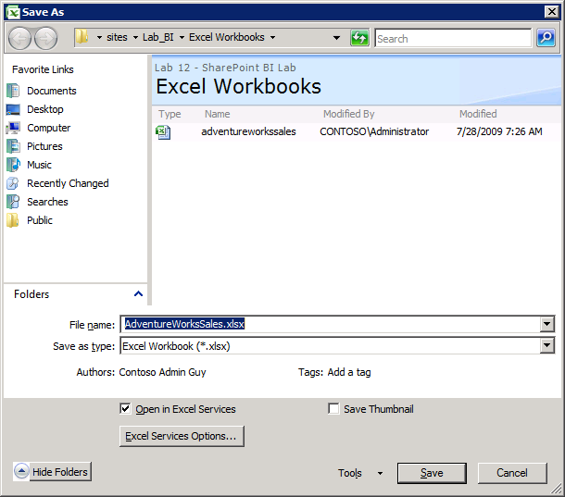

1. In the **Show** tab, change the value of the dropdown list from **Entire Workbook** to **Sheets**. Unselect **Sheet2** and **Sheet3** so that only **Sheet1** is published. Click **OK** to save your changes and dismiss the **Excel Services Options** dialog.

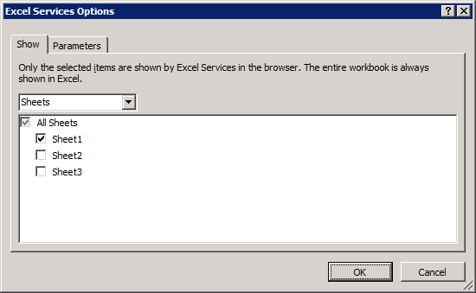

1. Click **Save** in the **Save As** dialog to publish the workbook to Excel Services. If you receive a prompt asking you if you want to overwrite the existing file, confirm by clicking **OK**. After you complete this step Excel will begin the publishing process. If this is the first time Excel Services has been started on your VM, it may take a minute to complete. When the publishing process is completed, you should now see your workbook inside the browser.

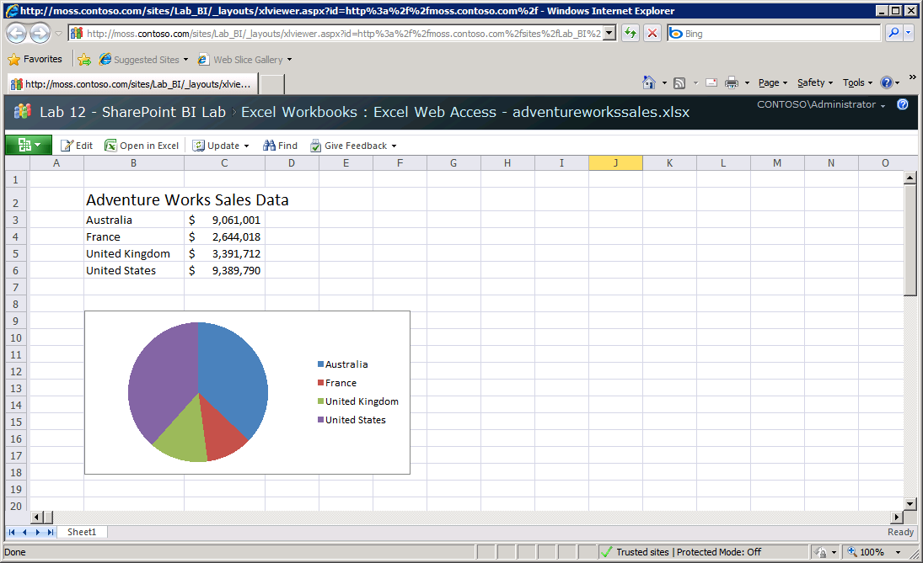

1. Now it is time to create a second Excel workbook to publish to Excel Services. This example will involve pulling data from a data source using a connection to SQL Server Analysis Services.
2. Navigate back to the **Excel Workbooks** document library.
3. Click on the **Documents** tab in the contextual **Library Tools** menu of the ribbon.
4. Click on the **New Document** button. This should launch the Excel 2010 client and give you a new empty workbook as a starting point.
5. From within Excel, save the workbook back to the document library with a name of PivotTable.xlsx. Note that this step is asking you to initially save the workbook using the standard Excel **Save As** command and not the Excel Services Publishing option.
6. Now it’s time to create a new PivotTable Report based on a cube that has been created from the Adventure Works database to track Internet sales figures. Begin by creating a data source to point to Analysis services.
7. Inside Excel, make sure PivotTable.xlsx is the active worksheet and that **A:1** is the selected as the active cell.
8. In the ribbon, select the **Data** Tab
9. In the **Get External Data** group, click on the Drop-down with the caption **From Other Sources**.
10. In the next dialog select **From Analysis Services**.
11. For server name, enter **WingtipServer**.
12. Make sure that the drop-down says **Adventure Works DW** and that the **Connect to a specific cube or table** checkbox is checked. Select the cube named **Adventure Works** in the list control and click **Next**.

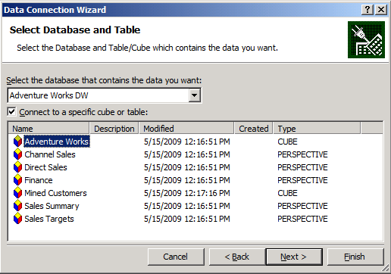

1. The final screen will have a caption of **Save Data Connection File and Finish**. Change the **File Name** to AdventureWorksCube.odc. Change the **Friendly Name** to **Adventure Works Cube**. Before you click finish, click on the button at the **Authentication Settings…** button at the bottom to display the **Excel Services Authentication Settings** dialog.

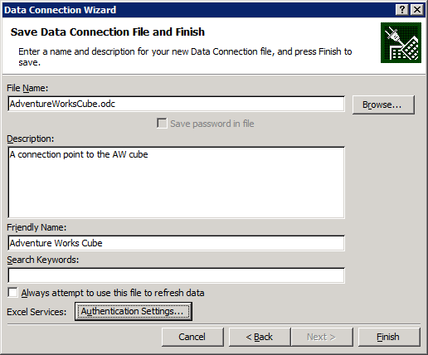

1. In the **Excel Services Authentication Settings** dialog, change the authentication setting to **None**. Click **OK** to save your changes.

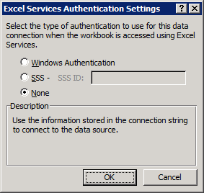

1. Click **Finish** to complete the **Data Connection Wizard**. If you get prompted that a file for that connection already exists, simply click yes.
2. Now you should be prompted by Excel to select how you wish to view the data in the **Import Data** dialog. Make sure that **PivotTable Report** is selected. Select **OK**.

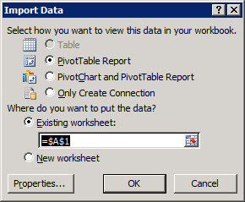

1. At this point, the connection has now been established between the workbook and the Adventure Works cube and you are ready to begin your work configuring a Pivot table.

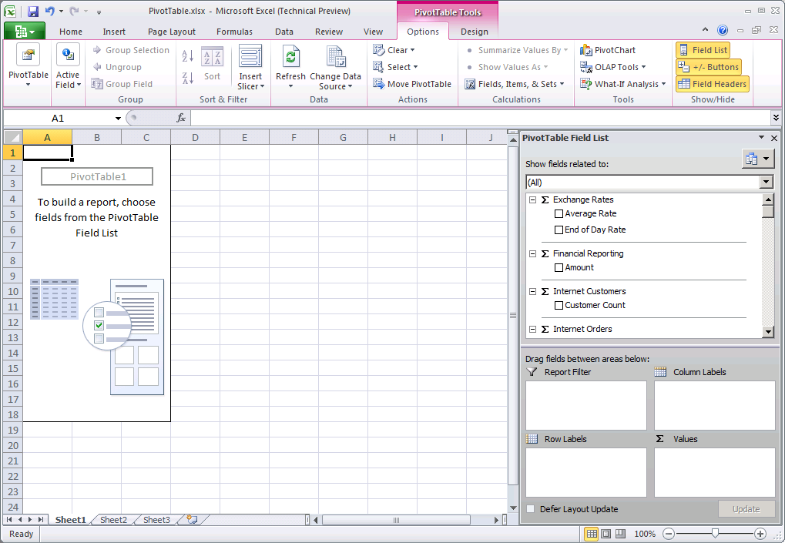

1. Now turn your attention to the **PivotTable Field List** inside the task pane on the right side of the screen. Locate the dropdown list right under the caption **Show fields related to**. This allows you to select a measure group. Select **Internet Sales** from the dropdown list. Inside the **Internet Sales** measure group, locate the set of items under **Σ Internet Sales.** Select the checkbox next to **Internet Sales Amount** which will add the **Internet Sales Amount** measure to the PivotTable report.

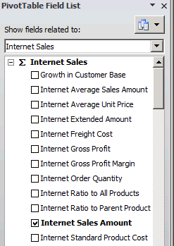

1. Scroll down the list of fields and locate the **Customer** section. Check the checkbox next to **Customer Geography** to add its hierarchy to the rows of the PivotTable report.



1. Scroll down the list of fields and locate the **Date** folder. Locate and expand the inner folder named **Calendar**. Check the checkbox for **Date.Calendar**.

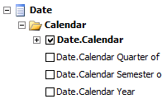

1. At this point, your PivotTable Report should look something like this:

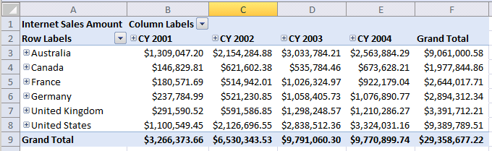

1. Creating a filter to drill down on data from 2002 by using the drop-down in the cell marked **Column Labels** to filter the Calendar Date Hierarchy. You can create this filter to only show Calendar Year **(CY) 2002** by un-checking CY 2001, CY 2003 and CY 2004.

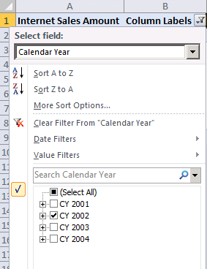

1. Now you must drill down into monthly sales figures for 2002. Right-click on **CY 2002** in the PivotTable and select **Expand/Collapse » Expand to Month.**
2. Now you are required to hide columns that show totals so only monthly totals show.
3. Right click on **January 2002** within the PivotTable and click on **Show/Hide Fields » Calendar Year** which will toggle that column to a hidden state.
4. Right click on **January 2002** a second time and this time select **Show/Hide Fields » Calendar Semester** to hide the totals column for **Calendar Semester**.
5. Right click on **January 2002** a third time and select **Show/Hide Fields » Calendar Quarter** to hide the totals column for **Calendar Quarter**.
6. You should now see a PivotTable Report that looks like the one below.

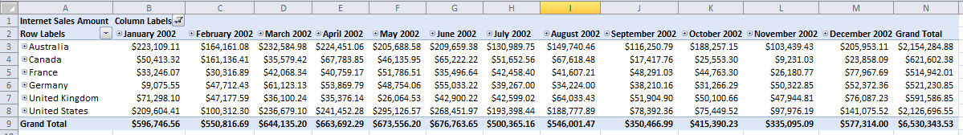

1. Now it’s time to create sparklines to compliment the PivotTable Report.
2. Copy the names of the countries in cells [A3:A8] and paste them into cells [A12:A17]**.**
3. Select cells [B12:B17]**.**
4. In the ribbon, go to the **Insert** tab. Select **Line** from the **Sparklines** group.
5. In the dialog box, select the data of the PivotTable – [B3:M8].
6. Click **OK**.
7. Now format the sparklines to add a high point marker and a low point marker.
8. In the ribbon, go to the Sparkline Tools **Design** tab and locate the **Marker Colors** button which has the icon with four colored squares.
9. Select **Marker Colors » High Point** » and select a color of Green.
10. Select **Marker Colors » Low Point** » and select a color of Yellow.
11. You sparklines should appear as the ones below.

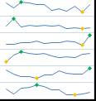

1. Now publish the workbook.
2. Select the **File** button.
3. In the left column, click on **Save & Send.**
4. In the middle column click on **Save to SharePoint.**
5. The **Save As** dialog appears. Click **OK** to publish your workbook to the **Excel Workbook** document library.

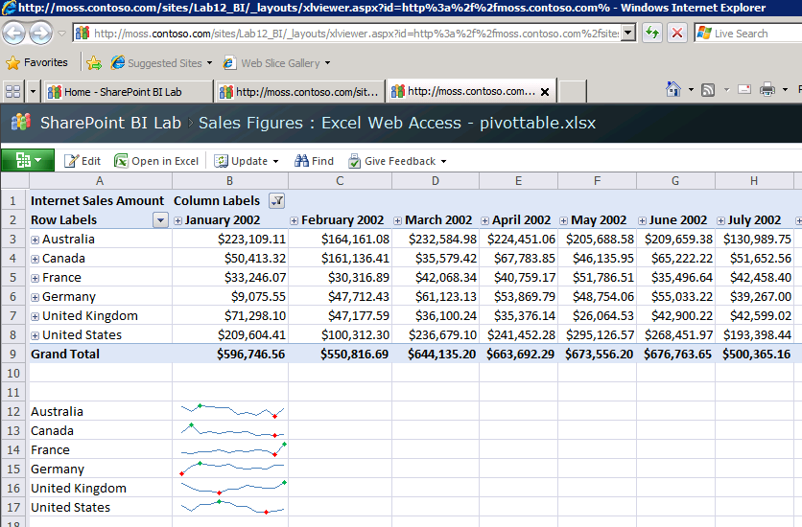

### Exercise 3: Building a Dashboard with PerformancePoint Services

In this exercise you will use the Dashboard Designer to create a KPI, a scorecard and a report from the same SQL Service Analysis Services cube that you used in the previous exercise. You will then create a dashboard that assembles all these pieces onto a single page and then you will deploy the dashboard to a SharePoint site.

1. You will begin by using **Central Administration** to make a change to the **PerformancePoint Services** configuration setting.
2. Open **Central Administration**.
3. In the **Application Management** section, click **Manage service applications**.
4. You should now be at the **Manage Service Applications** page as shown in the following screenshot. Look down the list of managed service applications and click on the one titled **PerformancePoint Service Application**. When you click this item, it will change color to show it is the selected item. Now go up to the ribbon on the page and click on the **Manage** button in the **Service Applications** ribbon tab so that you can navigate to the main configuration page for **PerformancePoint Service Application**.
5. You should now be at the main configuration page for **PerformancePoint Service Application**. Click on the link titled **PerformancePoint Service Application Settings**.

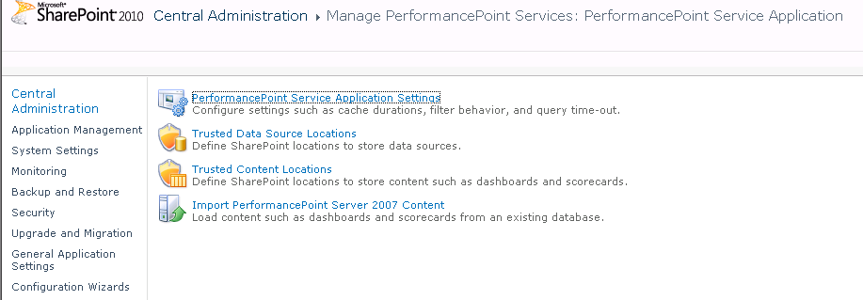

1. You should now be at the **PerformancePoint Service Application Settings** page as shown in the following screenshot. Look down the page to get an idea of the types of settings that are tracked by PerformancePoint Services. The one thing you need to do on this page is to change the **User Name** setting inside the **Unattended Service Account** section. If the **User Name** is already set to **WINGTIP\Administrator**, you do not have to do anything. If the **User Name** is set to something else, configure as WINGTIP\Administrator account.

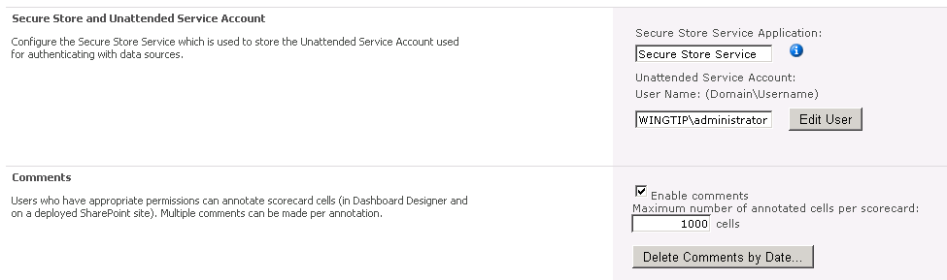

1. Click the **OK** button on the **PerformancePoint Service Application Settings** page to save changes.

**Note:** If you get errors while trying to make this update, it is likely that the **Secure Store Service** application is not yet configured with a key. Simply navigate back to the **Manage service applications page**, select the **Secure Store Service** and click the **Generate New Key** button. When prompted for a password, use the same password used throughout the labs.

1. Using the browser, navigate to the site created at **http://intranet.wingtip.com/sites/BusinessIntelligence**. Note that this site has been created from the Business Intelligence Center site template.
2. Now it is time to launch the **Dashboard Designer** application. Do this by first clicking the **PerformancePoint Content** link in the Quick Launch Bar and then clicking the **Add new item** link. Following these steps should launch the **Dashboard Designer** rich client application.

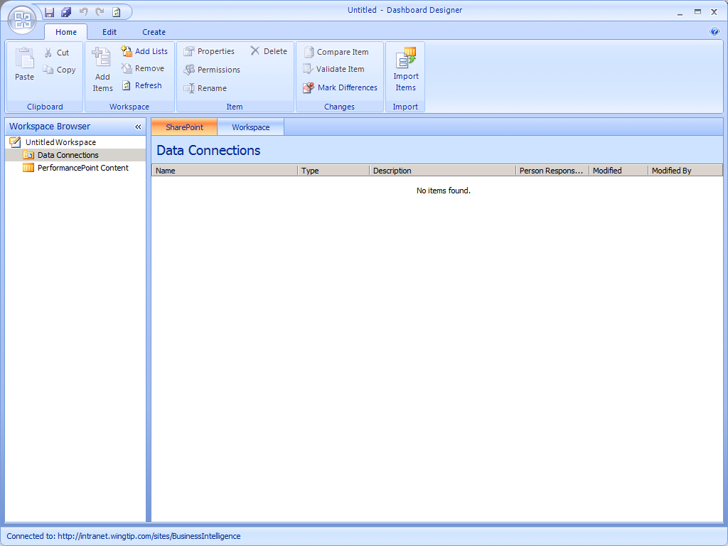

1. Create a new data source to a SQL Server Analysis cube.
2. Right-click on the **Data Sources** folder on the left-hand side of the page and select **New Data Source** to bring up the **Select a Data Source Template** dialog.
3. In the **Select a Data Source Template** dialog, select the **Multidimensional** category and then the **Analysis Services** template and then click **OK**.

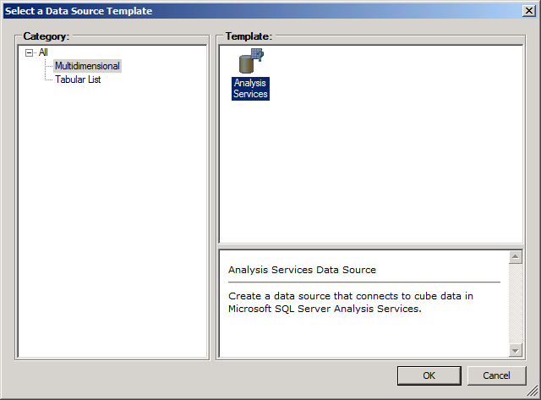

1. Once the data source has been created, rename it to **AdventureWorks**.
2. Now you will configure the connection for this data source. Select the **Editor** tab in the Workspace on the right-hand side of the screen, go through the following steps to configure the connection for the **AdventureWorks** data source.

**Connection Settings:** Use Standard Connection

**Server**: WingtipServer

**Database**: Adventure Works DWR2

**Cube**: Adventure Works

**Authentication**: Unattended Service Account

1. Click on the **Test Data Source** button to verify all the connection settings.

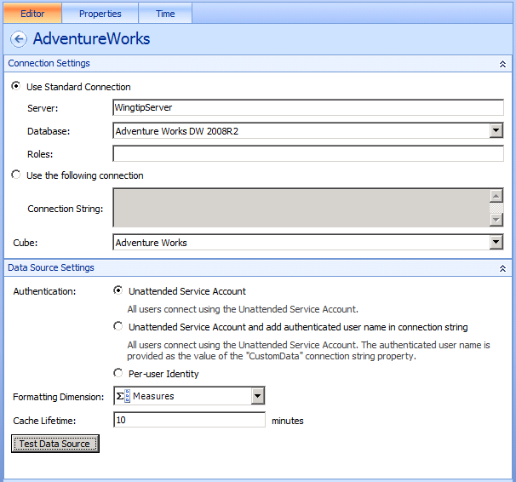

1. Click on the **Time** tab in the Workspace and follow these steps.
2. In the **Reference Data Mapping** section, click the down arrow of the **Time dimension** dropdown list and select **Date.Date.Calendar**.
3. In the **Reference Member** section click on the **Browse** button which will bring up the **Select Members** dialog. Expand the **All Periods** node, then the **CY 2008** node, then the **H1 CY 2008** node, then the **Q1 CY 2008** node, then the **January 2008** node, and select the **January 1, 2008** node and click **OK**.
4. For the Hierarchy level select a value of **Day**.
5. In this step you will set a reference date. This is required because the AdventureWorks database do not have data through the current time period. Enter a data of **1/1/2009** so that the first day of 2009 maps to the first day of 2008. In later steps, this will allow you to see values to things such as month-to-date sales figures as if it were 2008.

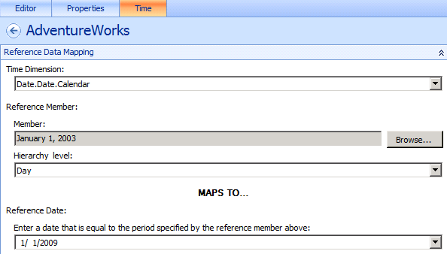

1. In the **Time Member Associations** section, map the appropriate time aggregations by assigning the following **Member Level** settings to the corresponding **Time Aggregation** values.

**Calendar Year:** Year

**Calendar Semester:** Semester

**Calendar Quarter:** Quarter

**Month:** Month

**Date:** Day

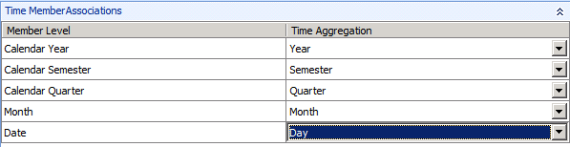

1. Right-click on the **AdventureWorks** data source in the Workspace Browser and click **Save** to save your work.
2. Now you will create your first KPI.
3. Right-click on the **PerformancePoint Content** node in the **Workspace Browser**. Using the ribbon select **Create » KPI**. Or you can use the context menu to do the same thing:

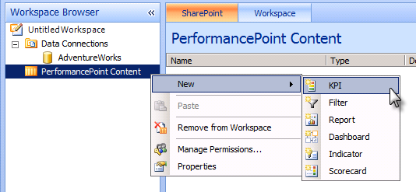

1. When prompted, name the KPI **Performance**.
2. In the Workspace click on the **Editor** tab.
3. Observe that in the **Actual and Targets** section there are already two indicator rows. The first is indicator row an actual indicator with a default name of **Actual** and the other is a target indicator with a default name of **Target**.
4. Right-click on the new KPI inside the **Workspace Browser** and click the **Save** command.
5. Modify the **Actual** indicator to track month-to-date performance.
6. Click inside the **Name** column replace with text Actual with the text MTD.
7. Click in the **Data Mappings** cell which as a value of **1 (Fixed Values)**. The **Fixed Values Data Source Mapping** dialog will appear.
8. Click on the **Change Source...** button. The **Select a Data Source** dialog will appear.
9. Select the **Workspace** tab inside the **Select a Data Source** dialog.
10. Locate and select the **AdventureWorks** data source.

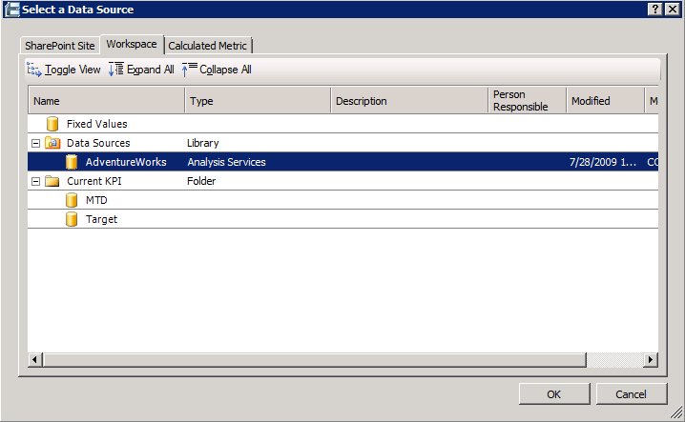

1. Click **OK**. The **Dimensional Data Source Mapping** dialog will take focus. In the **Select a Measure** drop down box, select the **Reseller Sales Amount** measure.
2. In the **Select Dimension** section, click the **New Time Intelligence Filter** button and the **Time Formula Editor** dialog will appear. In the **Time Formula** text box, type in the text MonthToDate. Click the **Preview** button to ensure the formula looks like [Date].[Calendar].[July 2003 to Date by Day].

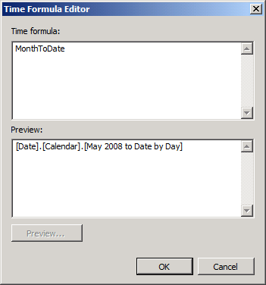

1. Click **OK** to accept changes and dismiss the **Time Formula Editor** dialog
2. Click **OK** again to accept changes and dismiss the **Dimensional Data Source Mapping** dialog.

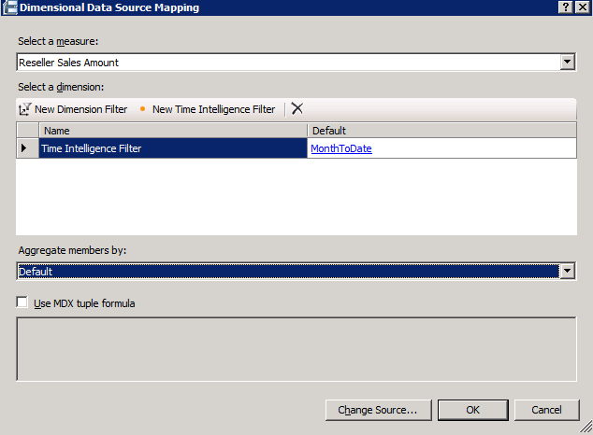

1. In the **Number Format** column of the **MTD** indicator, click the **"(Default)"** text. The **Format Numbers** dialog will appear. In the **Format** dropdown box select **Currency** and then click **OK**.

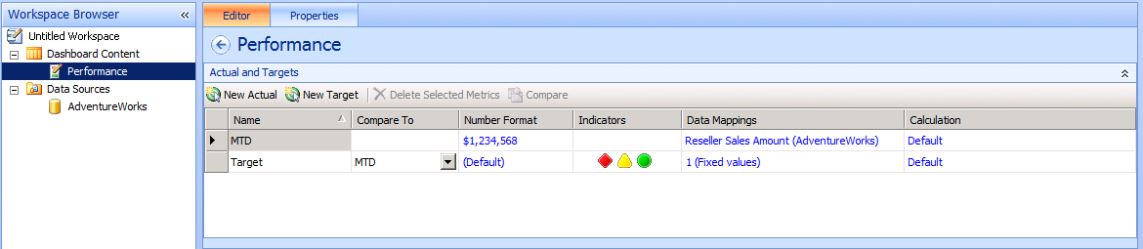

1. Save your work by right-clicking the **Performance** KPI and clicking **Save**.
2. Create a second actual indicator to track quarter-to-date performance. Many of the steps here will be identical to what you did when configuring the first actual indicator.
3. In the **Workspace** pane, click on the **New Actual** button to create a new actual indicator.
4. Click inside the **Name** column replace with text Actual with the text QTD.
5. Click in the **Data Mappings** cell which as a value of **"1 (Fixed Values)"**. The **Fixed Values Data Source Mapping** dialog will appear.
6. Click on the **Change Source...** button. The **Select a Data Source** dialog will appear.
7. Select the **Workspace** tab inside the **Select a Data Source** dialog.
8. Locate and select the **AdventureWorks** data source.
9. Click **OK**. The **Dimensional Data Source Mapping** dialog will appear.
10. In the **Select a Measure** drop down box, select the **Reseller Sales Amount** measure
11. In the **Select Dimension** section, click the **New Time Intelligence Filter** button and the **Time Formula Editor** dialog will appear.
12. In the **Time Formula** text box, type in the text QuarterToDate. Click the **Preview** button to ensure the formula looks like [Date].[Calendar].[Q2 CY 2008 to Date by Day].
13. Click **OK** to accept changes and dismiss the **Time Formula Editor** dialog
14. Click **OK** again to accept changes and dismiss the **Dimensional Data Source Mapping** dialog.
15. In the **Number Format** column of the **QTD** indicator, click the "(Default)" text. The **Format Numbers** dialog will appear. In the **Format** dropdown box select **Currency** and then click **OK**.

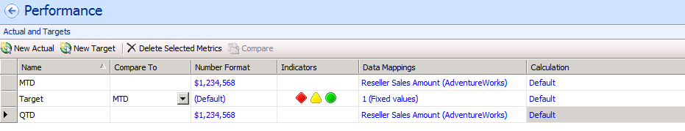

1. Create a third actual indicator to track year-to-date performance.
2. In the **Workspace** pane, click on the **New Actual** button to create a row for a new actual
3. Click inside the **Name** column replace with text Actual with the text YTD.
4. Click in the **Data Mappings** cell which as a value of **"1 (Fixed Values)"**. The **Fixed Values Data Source Mapping** dialog will appear.
5. Click on the **Change Source...** button. The **Select a Data Source** dialog will appear.
6. Select the **Workspace** tab inside the **Select a Data Source** dialog.
7. Locate and select the **AdventureWorks** data source.
8. Click **OK**. The **Dimensional Data Source Mapping** dialog will appear.
9. In the **Select a Measure** drop down box, select the **Reseller Sales Amount** measure
10. In the **Select Dimension** section, click the **New Time Intelligence Filter** button and the **Time Formula Editor** dialog will appear.
11. In the **Time Formula** text box, type in the text YearToDate. Click the **Preview** button to ensure the formula looks like [Date].[Calendar].[CY 2008 to Date by Day].
12. Click **OK** to accept changes and dismiss the **Time Formula Editor** dialog
13. Click **OK** again to accept changes and dismiss the **Dimensional Data Source Mapping** dialog.
14. In the **Number Format** column of the **QTD** indicator, click the **"(Default)"** text. The **Format Numbers** dialog will appear. In the **Format** dropdown box select **Currency** and then click **OK**. At this point, your screen should look like this:

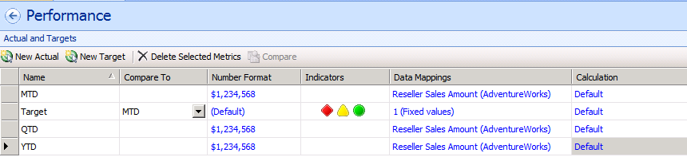

1. Modify the **Target** indicator to track target amount for the year.
2. Click the **Name** column and change the indicator name from **Target** to **Target for the year**.
3. In the **Compare To** column click on the drop down box and select the **YTD** actual indicator.
4. Click on the **Number Format** column and choose **Currency** formatting.
5. In the **Data Mappings** column select the **1 (Fixed values)** text. The **Fixed Values Data Source Mapping** dialog will appear.
6. Click the **Change Source...** button. The **Select a Data Source** dialog will appear.
7. Select the **Calculated Metrics** tab and then select the **Blank Calculation** template. Click **OK**.

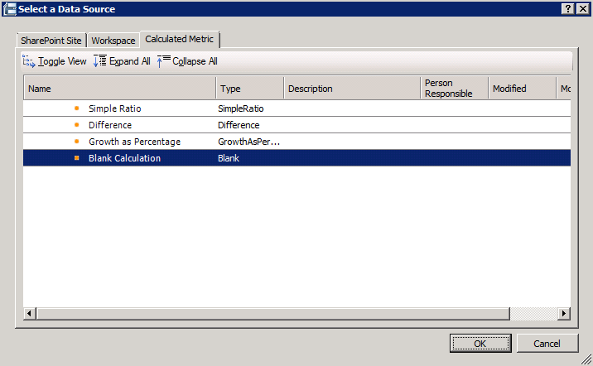

1. Select the **Value2** row and click the **Delete** button to remove it.
2. Click on the **Name** Value1 and change its value to LastYearSales.
3. Click on the **Source** text **"1 (Fixed values)"**. The **Fixed Values Data Source Mapping** dialog will appear.
4. Click **Change Source** button. The **Select a Data Source** dialog will appear.
5. Click on the **Workspace** tab. Select the **AdventureWorks** data source and click **OK**. Now the **Dimensional Data Source Mapping** dialog will appear.
6. Expand the **Select a Measure** drop down box and select **Reseller Sales Amount**.
7. In the **Select a dimension** section click the **New Time Intelligence Filter** button. The **Time Formula Editor** dialog will appear.
8. In the **Time Formula** text box type the formula Year-1. Click the **Preview** button to ensure that a valid formula is returned.

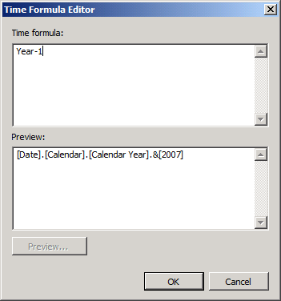

1. Click **OK** to save your changes and dismiss the **Time Formula Editor** dialog.
2. Click **OK** to save your changes and dismiss the **Dimensional Data Source Mapping** dialog
3. At this point, you should be back at the **Calculated Metrics Data Source Mapping** dialog. Locate the **Formula** text box and type LastYearsSales*1.25.

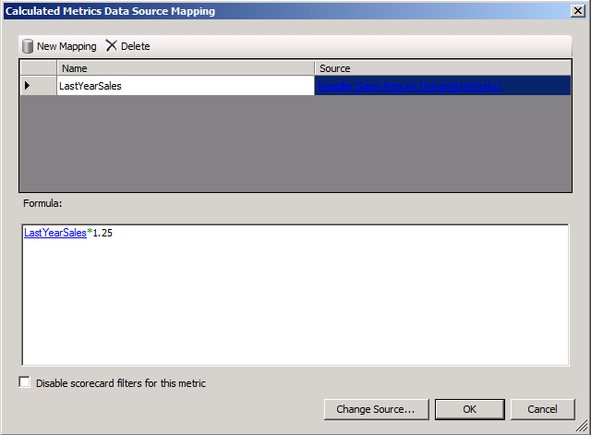

1. Click **OK** to save your changes and dismiss the **Calculated Metrics Data Source Mapping** dialog.
2. Within the Workspace View, make sure target indicator named **Target for the year** as shown in the screenshot below. Look below in the **Thresholds** section and you should see target values for **Best**, **Threshold** 2, **Threshold 1** and **Worst**. Change the **Best** threshold to **135%** and change the **Threshold 2** threshold to **85%**. Leave the other two thresholds at their default values.

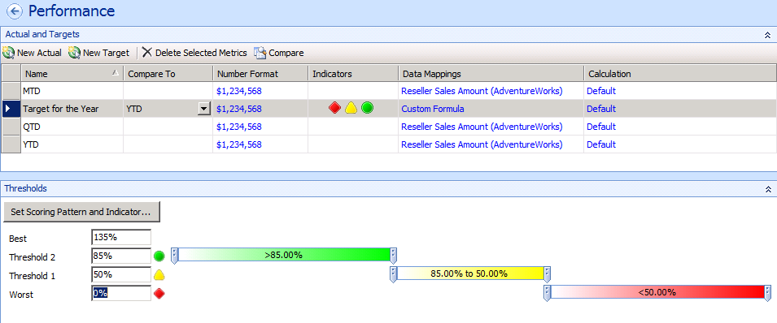

1. Right-click the **Performance** KPI in the Workspace Browser pane and click **Save**.
2. Now, you will move on to create a scorecard to expose your KPI.
3. Right-click on the **PerformancePoint Content** node in the Workspace Browser pane. Expand the **New** node and select **Scorecard** to create a new scorecard. The **Select a Scorecard Template** dialog will appear. Uncheck the **Use wizards to create scorecards** and click **OK**.
4. Click on the **Properties** tab in the Workspace pane. In the **General Properties** section select the **Name** text box and replace the name **New Scorecard** with **Performance By Country**.
5. Right click on the **Performance By Country** scorecard in the Workspace Browser pane and select **Save**.
6. Click on the **Editor** tab in the Workspace Pane. Locate the **Details** pane on the right-hand side of Dashboard Designer. Inside the **Details** pane, expand the **KPIs** node until you locate the **Performance** KPI. Left-click and drag the **Performance** KPI to the **Performance By Country** scorecard designer area to the left that is labeled **Drop items here**.

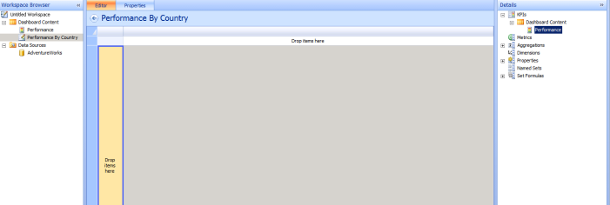

1. Up in the ribbon, select the **Edit** tab of Dashboard Designer. Inside the **Edit** tab within the **View** group, locate and click the **Update** button. The **Performance** KPI should render displaying data in each of the cells.

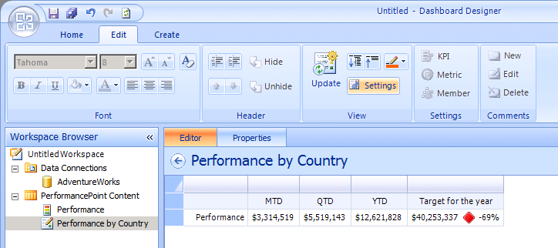

1. Locate the **Data Source** pane in the bottom right side of Dashboard Designer and make sure the **AdventureWorks** data source is selected in the dropdown list.

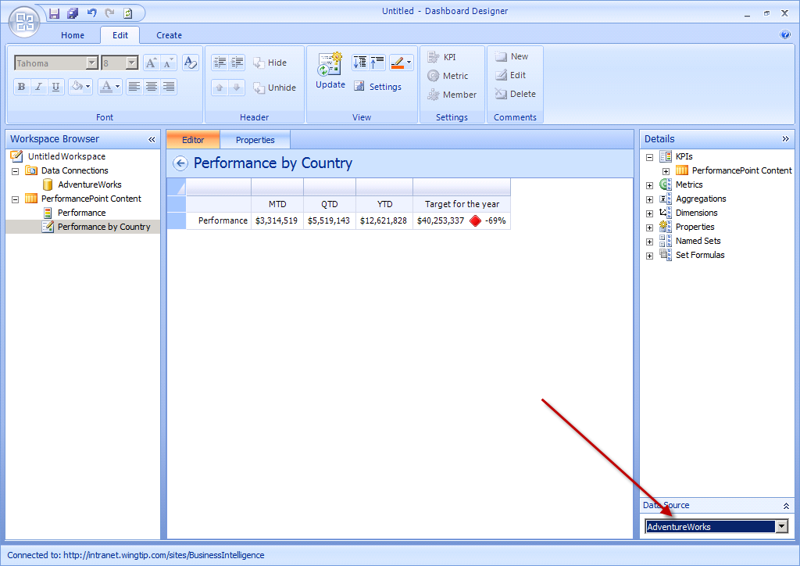

1. Expand the **Dimensions** node in the Details pane and locate the **Geography** dimension.

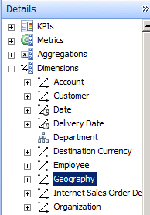

1. Drag the **Geography** Dimension into the Workspace and release it when the right side of the **Performance** cell is highlighted. The **Select Members** dialog will appear.

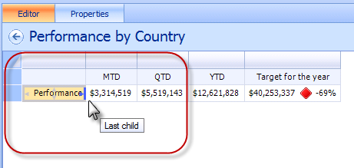

1. Right click the **All Geographies** member. Expand the **Autoselect Members** menu. Click the menu item with the caption **Select Country**.

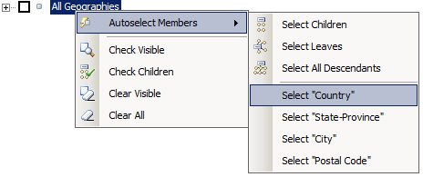

1. Up in the ribbon, select the **Edit** tab of Dashboard Designer. Inside the **Edit** tab within the **View** group, locate and click the **Update** button. The **Performance** KPI should render displaying data in each of the cells.

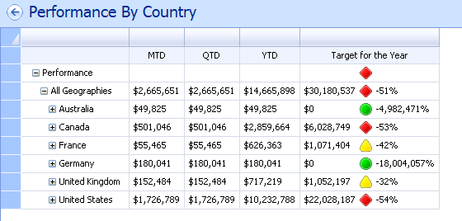

1. Now you will create a Report which will display a chart.
2. In the Workspace Browser pane, right click on the **PerformancePoint Content** node, expand the **New** menu and select **Report**. The **Select a Report Template** dialog appears.
3. Select the **Analytic Chart** template and click **OK**.
4. When prompted for a **data source**, pick **AdventureWorks** & click **Finish**.
5. In the Workspace select the **Properties** tab. When prompted **Name** to **Performance By Year**.
6. Right click on the **Performance By Year** report and click **Save**.
7. In the Workspace Browser pane, ensure that the **Performance By Year** report is selected. Click the **Design** tab in the Workspace pane.
8. In the **Details** pane on the right-hand side of the screen, expand the **Measures** node.
9. Locate the **Reseller Sales Amount** measure and drag and drop in into the **Bottom Axis**.
10. Collapse the **Measures** node in the **Details** pane and expand the **Dimensions** node.
11. Within the **Geography** dimension, locate the **Country** dimension. Drag and drop the **Country** dimension to the Series axis
12. Up in the ribbon, select the **Edit** tab. Drop down the **Report type** button and select the **Pie Chart** option
13. Right click on the **Performance By Year** report and click **Save**.
14. Now, it’s time to create a dashboard.
15. Using the ribbon select **Create » Dashboard**. The **Dashboard Page Template** dialog will appear.
16. Select the **2 Columns** template and click **OK**.

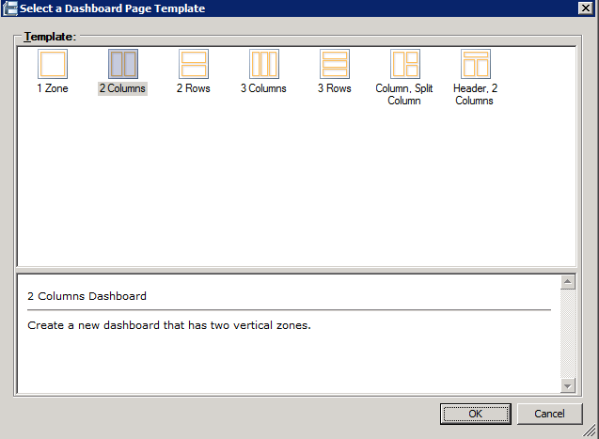

1. When prompted set the **Name** to **Performance Dashboard** and **Save** your work.
2. Now it’s time to configure the dashboard:
3. In the Workspace Browser pane, ensure that **Performance Dashboard** is selected.
4. In the Workspace, select the **Editor** tab.
5. Inside the **Pages** section you should see a single page named **Page1**. Rename this page to **Performance**.
6. In the **Details** pane, expand the **Scorecards** node until you locate the **Performance by Country** scorecard. Drag and drop the **Performance By Country** scorecard on the **Right Column** zone of the dashboard designer.
7. In the **Details** pane, collapse the **Scorecards** node and expand the **Reports** node.
8. Locate the **Performance By Year** report. Drag and drop the **Performance By Year** report into the **Left Column** zone.

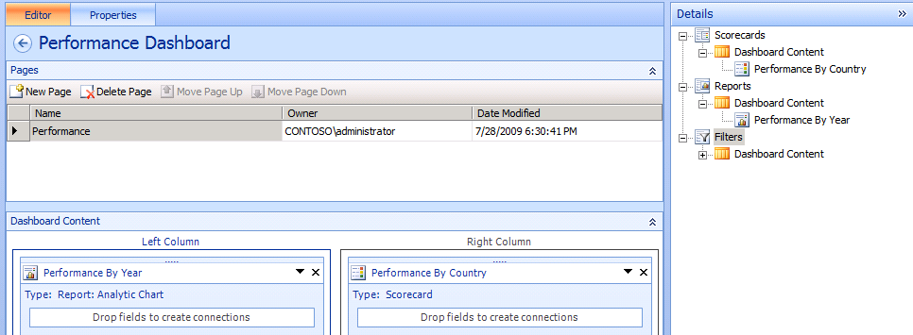

1. Right-click on **Performance Dashboard** and click **Save**.
2. In the Workspace Browser pane, right click the **Untitled Workspace** node. Select the **Save** option. In the **File Name** text box type in **PerformancePoint Lab** and click **Save**.
3. Now, it is time to deploy what you have done into SharePoint.
4. In the Workspace Browser pane, right click **Performance Dashboard** and select the **Deploy to SharePoint...** option.

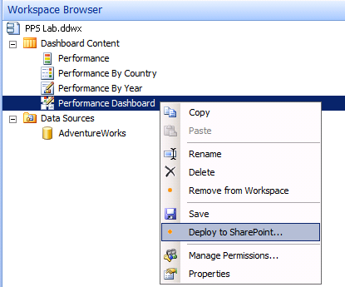

1. The **Deploy To** dialog will open and ask you to select one the of the document libraries in the site at **http://intranet.wingtip.com/sites/BusinessInteligence**. Select the **Dashboards** document library and ensure that the Master Page selected is **v4**. Click **OK**.

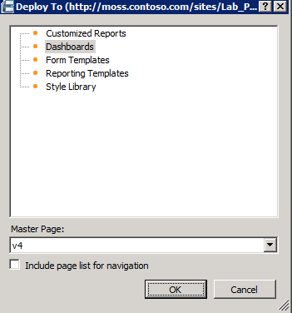

1. An Internet Explorer window should open and will render the dashboard.

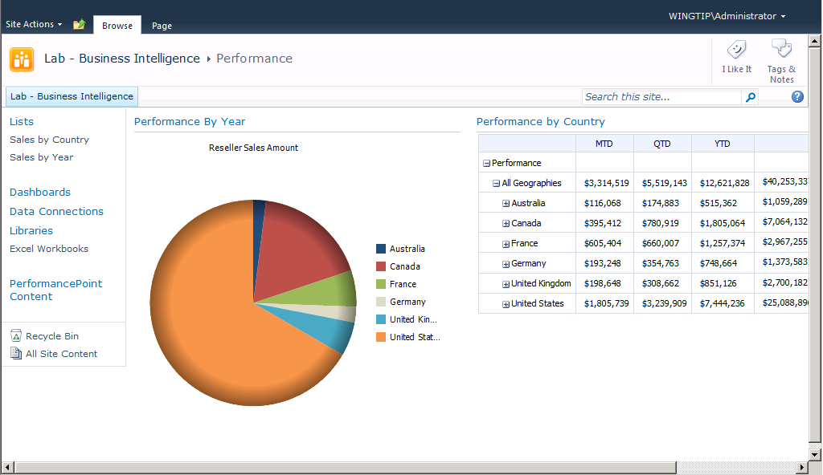

In this exercise you used the PerformancePoint Dashboard Designer to create some new KPIs and add them to a scorecard in a SharePoint site.